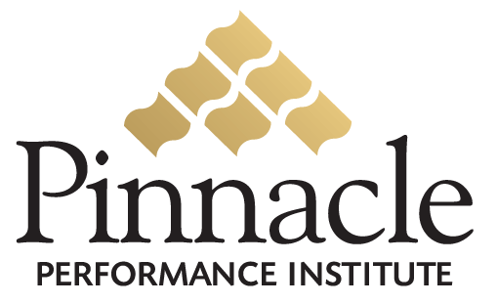

Affiliate Sales Commissions

The Pinnacle Performance Institute provides compensation to its Sales Affiliates for the sales of Pinnacle Performance Solutions (PMS).
Qualification
Each approved Sales Affiliate must become qualified to accurately and professionally represent the Pinnacle Performance Institute. Pinnacle utilizes its own PMS to maximize the performance of its sales team. Each Sales Affiliate must actively participate in Pinnacle’s Sales PMS to complete the ongoing courses and other requirements defined by Pinnacle in order to continue their representation of the Pinnacle Performance Institute.
Sales Commission
Qualified Sales Affiliates can earn a total commission of 25% for the first billable year of customer. They will also receive a residual commission of 5% after the first year.

